|  |  |  |
| --- | --- | --- |
| **LAB321Assignment** | **Type:** | **Long Assignment** |
| **Code:** | **J3.L.P0045** |
| **LOC:** | **100** |
| **Slot(s):** | **5** |

**Title:** Timetable management

**Background**

In the school timetable is very important, it helps schools manage teaching plan for teachers that are reasonable and most scientific. Schedule also help students manage their learning plan in each term. before each Semester, Academic staff must be make schedule for each class or each course, to tearcher and student can prepare teaching plan and learning plan.

**Program Specifications**

Program a web site to Add and View Timetable

**Features:**

This website contains 2 main functions

* Function 1 : Default page : ( see PIC 01)
  + Display current week’s Time table of class (PIC 01)
  + Can display Time table byFrom date To date (see Pic 01)
  + Each Time Table in a row contains
    - Date
    - Slot
    - Start time and end time
    - Class name/Course Name
    - Teacher Account
    - Room No
  + Link Button Add new Time table

Redirect to Page add new Time table when click button **Add timetable**

* Function 2 : Add Timetable ( PIC 02)
  + Data input
    - Input date with dd/MM/yyyy format
    - Input slot with number format
    - Input Room no with number format
    - Allow input teacher account
    - Chose class/course from list
  + Save and validate data
    - Validate data
      * Date: not null, dd/MM/yyy format
      * Slot: must be number > 0
      * Room No: Must be number > 0
      * Teacher: Must be available in database
      * Class/ Course: must be available in database
      * One Room cannot arrange for 2 class/course in the same time
      * One teacher cannot teach 2 class/course in the same time
      * Show alert or message when data invalid
    - Save data
      * When Save successfully show alert or message to user and then redirect to **Time table list** page
      * If error occur, show alert or message to user

You do not need to write interface for admin control panel, you can add data manually (use SQL SERVER Management studio).

Note: All data must be load from database, not hard code in page.

**Slot:** should be store in database with fields: slot no, start time, end time.

***Expectation of User interface:***

***(This prototype is creation by .Net IDE, so you do not need to design the user interface absolute accuracy , but all function must work properly)***

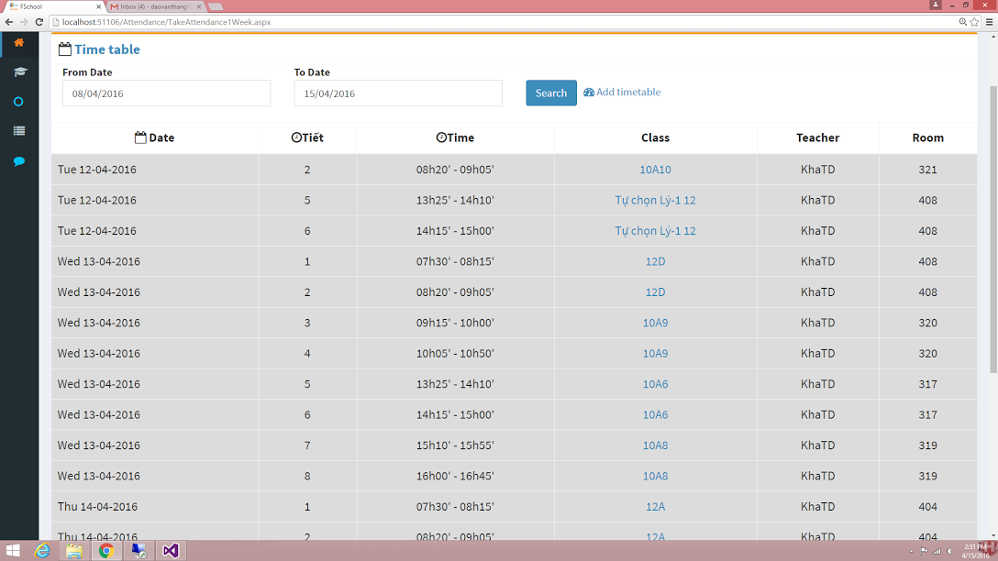

Pic 01 : Home Page ( TOP)

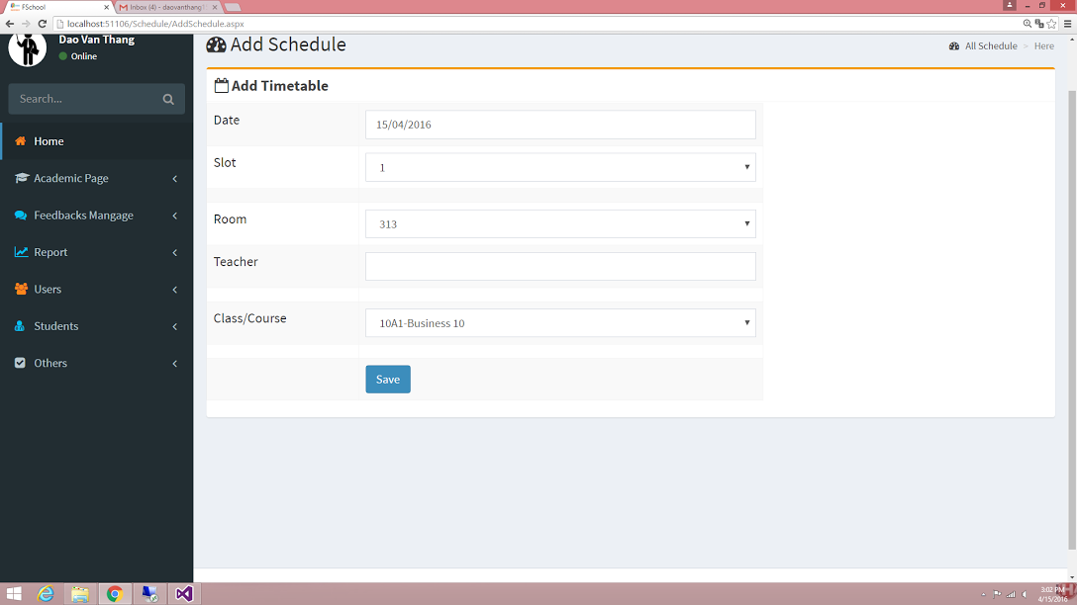

PIC 2 :Add Schedulepage

**Guidelines**

* Step 1 : Create web layout
* Step 2 : Create prototype
* Step 3 : Design database base on created prototype
* Step 4 : Code & Test